AMEX Sales OCH Integration



This is a preliminary document and may be changed substantially.
The information contained in this document represents the current project behavior and data flow mechanism

Table of Contents
AMEX OCH Integration 5
1 Document History 5
2 Introduction 5
2.1 Purpose of Document 5
2.2 Scope of document 5
2.3 Scope of Requests 5
3 AMEX Program Configuration APIs 5
3.1 Post – /Programs/AMEX 6
3.1.1 Request Body 6
3.1.2 Response 8
3.2 Get – /Programs/AMEX 8
3.2.1 Response 8
4 AMEX Integration Sales Journey 11
5 AMEX Integration APIs (Operations) 12
5.1 Post- v1/Token – Authorization 12
5.2 Post – v1/Policy (Enroll) 13
5.2.1 Headers 13
5.2.2 Request Body 13
5.2.3 Response 16
5.3 /{{ProgramCode}}/certificates?phoneNumber=1234567890 17
5.3.1 Headers 18
5.3.2 Response 18
5.4 Get – /{{ProgramCode}}/certificates/{{CertificateNumber}} 19
5.4.1 Headers 19
5.4.2 Response 19
5.5 Get – /{{ProgramCode}}/manufacturers 23
5.5.1 Headers 23
5.5.2 Response 23
5.6 Get –/{{ProgramCode}}/equipments?manufacturerId=a0a499d8dc754b5a98871d2e3e001602 26
5.6.1 Headers 26
5.6.2 Response 26
5.7 Get – /{{ProgramCode}}/products 28
5.7.1 Headers 28
5.7.2 Response 29
5.7.3 Get Product Journey 29
6 Debugging and Diagnostics 30
7 Resource Detail 30
7.1 AMEX deployment details 30
7.2 Reference 31

AMEX OCH Integration

Document History
Date | Comments | Published By | Reviewed By
05-13-2024 | Version 1.0 – Initial Draft | Raman Kumar

Introduction

Purpose of Document
The document lists all following HTTP APIs that AMEX requires to integrate with Elita System
- Get Token
- Enrol Certificate
- Get Certificate
- Get Equipment
- Get Manufacturers
- Get Products
- Search Certificate
Elita system is also integrated with OCH external API to check the device eligibility.
- Device Eligible API

Scope of document
This document defines the above policy designed for AMEX.

Scope of Requests
Amex can call all the provided APIs with the specified request structure below in document in json format.

AMEX Program Configuration APIs

These APIs are used to define configuration for AMEX in a way to integrate AMEX APIs with ELITA. There are many configurations which is required for the integration and that needs to be done prior to use AMEX Apis like (Dealer Code, Company Group Code, Risk Type Code etc.).
These APIs are used to Add / Update / Delete configuration for a specific configuration code. Configuration code is used as a key in the API url and the same code will be used as to perform other operations on Configurations like get. put.

Post – /Programs/AMEX

Base URL : https://apim-elita-modl-de.azure-api.net/elita/d1/apim-program/v1/programs/AMEX
Ocp-Apim-Subscription-Key: 495796af3c914c229906eb2dd4b69b7d

Request Body

Sample Json Payload for AMEX Client:
{
"partitionKey": "AMEX",
"comments": "Amex added billing cycle",
"code": "AMEX",
"name": "American Express",
"policy": [
{
"code": "DealerCode",
"value": "AMEX"
},
{
"code": "CompanyCode",
"value": "ADG1"
},
{
"code": "RiskTypeCode",
"value": "TECH SUPPORT"
},
{
"code": "cancellationCode",
"value": "000"
},
{
"code": "PaymentInstrumentType",
"value": "D"
},
{
"code": "PaymentType",
"value": "AssurantGenBilling"
},
{
"code": "BillingFrequency",
"value": "1"
},
{
"code": "BillingCycle",
"value": "1"
}
],
"claim": [
{
"code": "DealerCode",
"value": "AMEX"
}
],
"decryption": null,
}

Response

201 Created

Get – /Programs/AMEX

Get the Program configuration based on configuration code

Response
{
"partitionKey": "AMEX",
"id": "4c6e39a0-48f9-437d-b902-458bd3f6fa4d",
"comments": "Amex added billing cycle",
"code": "AMEX",
"name": "American Express",
"active": true,
"policy": [
{
"code": "DealerCode",
"value": "AMEX"
},
{
"code": "CompanyCode",
"value": "ADG1"
},
{
"code": "RiskTypeCode",
"value": "TECH SUPPORT"
},
{
"code": "cancellationCode",
"value": "000"
},
{
"code": "PaymentInstrumentType",
"value": "D"
},
{
"code": "PaymentType",
"value": "AssurantGenBilling"
},
{
"code": "BillingFrequency",
"value": "1"
},
{
"code": "BillingCycle",
"value": "1"
}
],
"claim": [
{
"code": "DealerCode",
"value": "AMEX"
}
],
"domain": null,
"lastModified": "2024-03-06T14:07:10.4687984Z",
"lastModifiedBy": "Reginald Jean-Mary",
"decryption": null,
"_rid": "y9xgAJW5tNgDAAAAAAAAAA==",
"_self": "dbs/y9xgAA==/colls/y9xgAJW5tNg=/docs/y9xgAJW5tNgDAAAAAAAAAA==/",
"_etag": "\"70029510-0000-1500-0000-65e8788e0000\"",
"_attachments": "attachments/",
"_ts": 1709734030
}

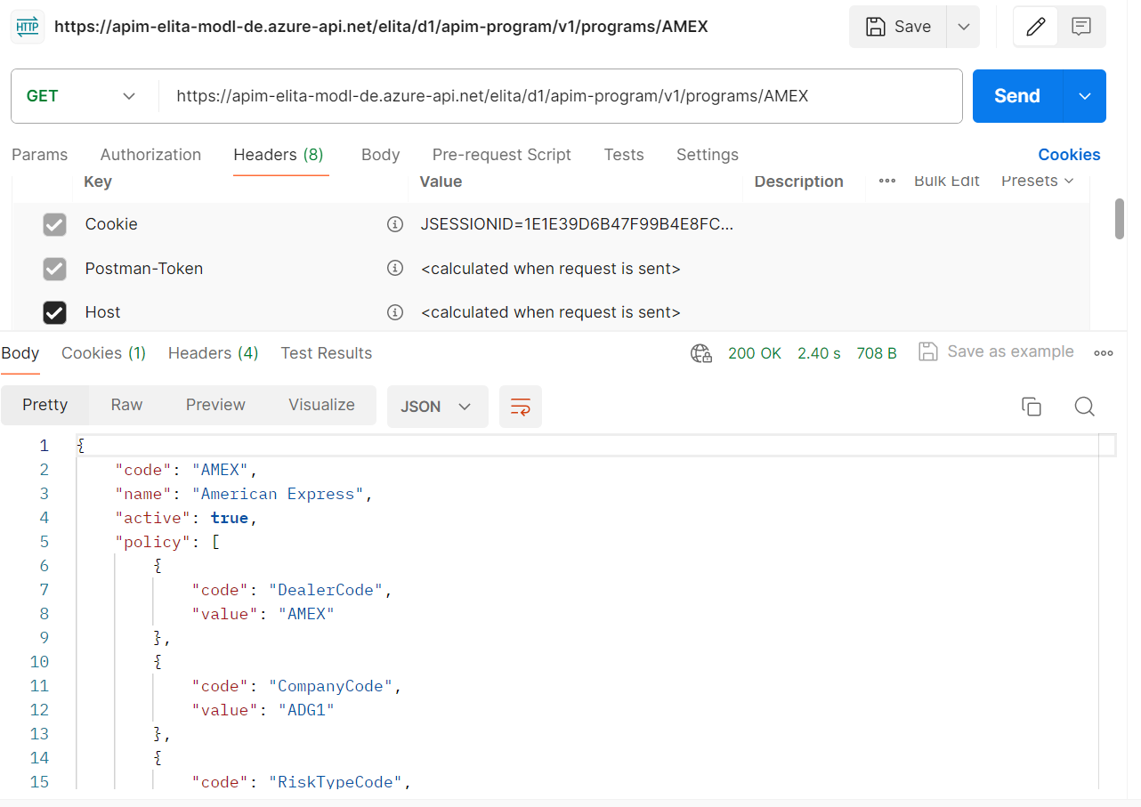

AMEX Integration Sales Journey
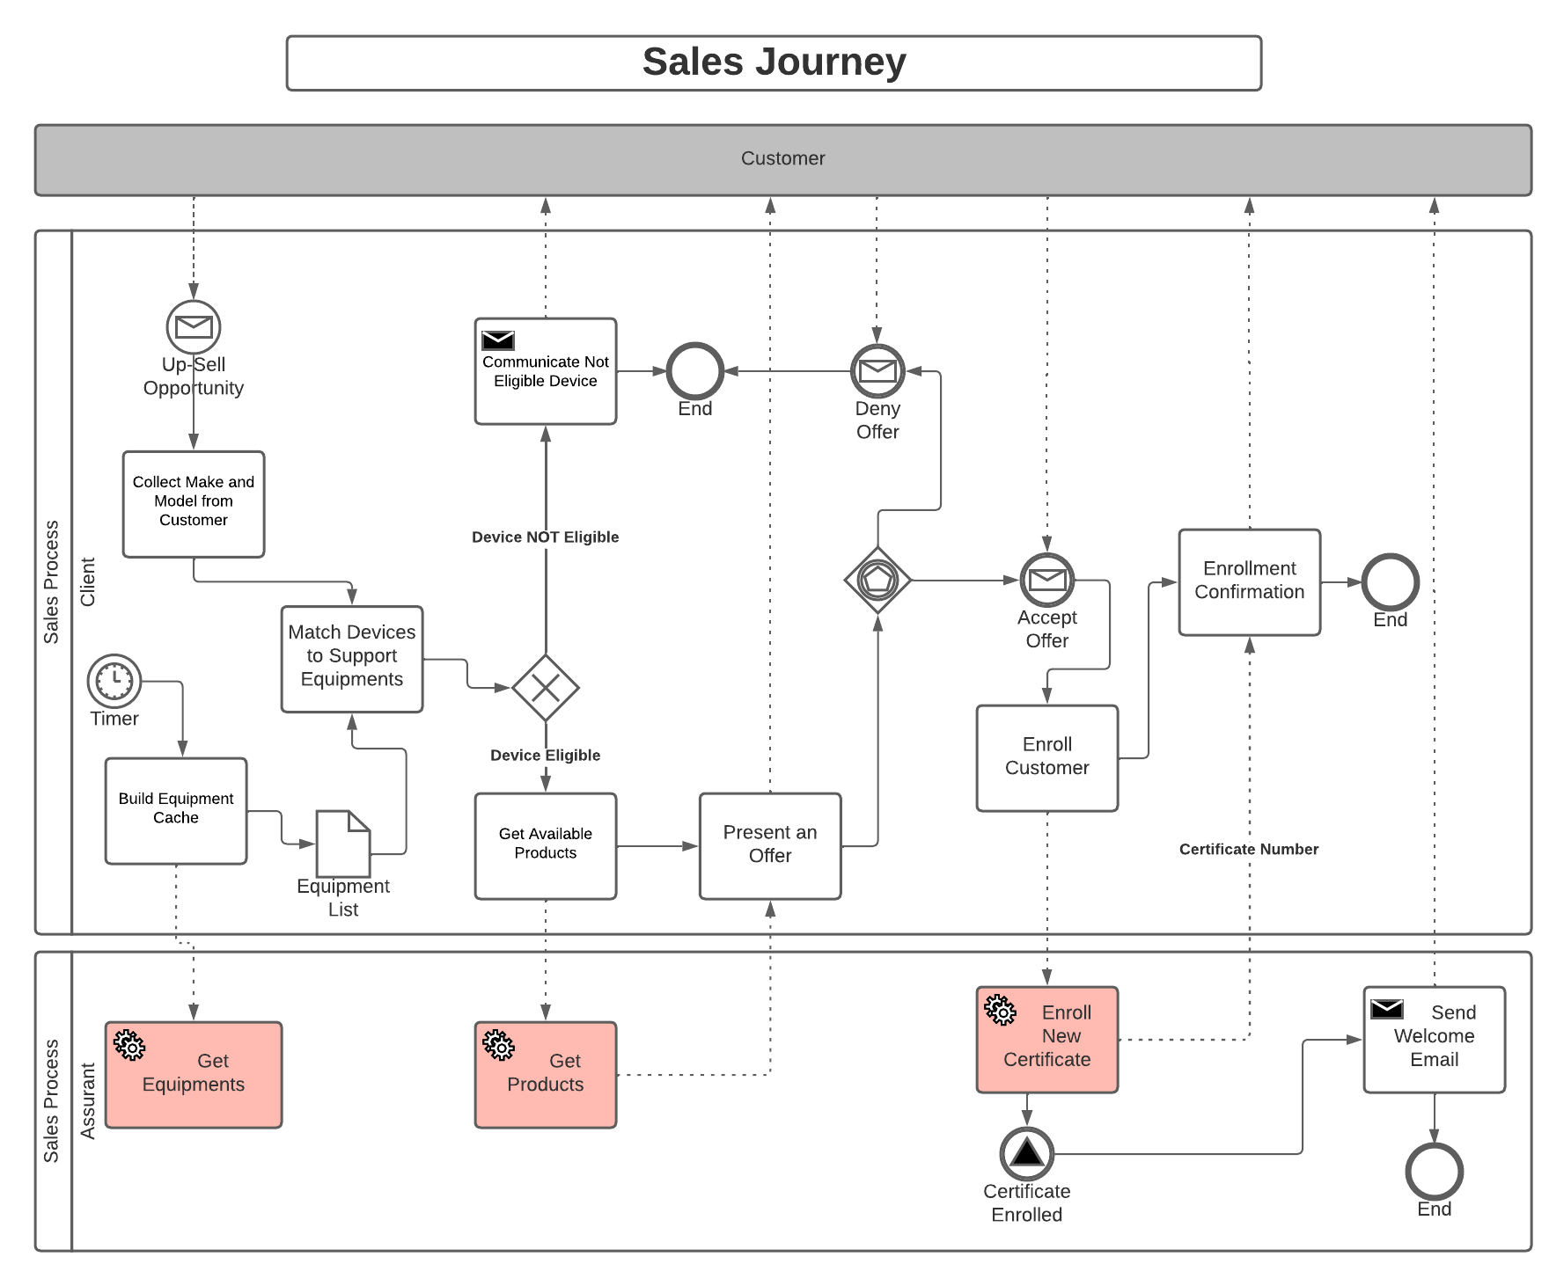

AMEX Integration APIs (Operations)

Post- v1/Token – Authorization
To be able to connect to this API client need to provide the Bearer token get it from our Security API
URL : https://apim-model.de.assurant.com/elita/d1/security/v1/token
The post request should be x-www-form-urlencoded with these fields:

Field | Value | Description
grant_type | client_credentials
client_id |  | Client id assigned to the client by Okta.
client_secret |  | Client secret provide by Okta for the client.
scope |  | Scope provide by Okta for the client.

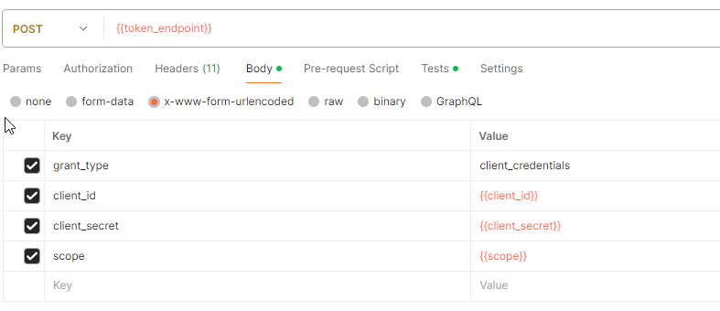
Response:
{
"token_type": "Bearer",
"expires_in": 3600,
"access_token": "***********************",
"scope": "read"
}

The "access_token" field received in the response should be use as token for the future calls.
To summarize the header requirements to call AMEX API we have:

Key | Value | Description
Ocp-Apim-Subscription-Key | ****** | APIM Subscription for AMEX
Authorization | Bearer ***** | The access token from Security API
Content-Type | application/json

Post – v1/Policy (Enroll)
This Post API is used to enroll certificate in Elita.
BASE Url : https://apim-model.de.assurant.com/elita/d1/amex-policy/v1/
Request URL: https://apim-model.de.assurant.com/elita/d1/amex-policy/v1/{{ProgramCode}}/certificates

Headers

Following Headers are required to call Enroll Policy

Header Key | Value | Description
Ocp-Apim-Subscription-Key | APIM Subscription Key | Key used to connect with Azure APIM instance
Authorization | Bearer Token | Token received from Get Token API based on client id and secret

Request Body

- Payment Instrument Type: Bank
{
"productSalesDate": "2020-08-14",
"product": {
"productCode": "MPR100000000000000H",
"equipment": {
"manufacturerName": "Apple",
"model": "iPhone 15 Plus 128GB Black",
"description": "iPhone",
"color": null,
"capacity": null,
"carrier": null,
"skuNumber": null,
"imeiNumber": "35387411265458",
"equipmentSalesDate": "2020-08-14"
}
},
"payment": {
"instrument": {
"instrumentType": "Bank",
"authorizationNumber": "F740320",
"authorizationSource": "External",
"ibanNumber": "DE89370400440532013000"
}
},
"certificateReferenceData": {
"clientReferenceNumber": "0190727851234"
},
"clientReferenceData": [
{
"name": "SALES_CHANNEL",
"value": "Online"
}
],
"customers": [
{
"firstName": "John",
"lastName": "Doe",
"birthPlace": {
"dateOfBirth": "1970-03-17"
},
"addresses": [
{
"addressType": "Home",
"address1": "Hauptstr.",
"address2": "45",
"city": "Frankfurt",
"postalCode": "60385",
"country": "DE"
}
],
"homePhone": "1234567890",
"emailAddress": "john.doe@gmail.com"
}
]
}

- Payment Instrument Type: Token
{
"productSalesDate": "2020-08-14",
"product": {
"productCode": "MPR100000000000000H",
"equipment": {
"manufacturerName": "Apple",
"model": "iPhone 15 Plus 128GB Black",
"description": "iPhone",
"color": null,
"capacity": null,
"carrier": null,
"skuNumber": null,
"imeiNumber": "35387411265458",
"equipmentSalesDate": "2020-08-14"
}
},
"payment": {
"instrument": {
"instrumentType": "TOKEN",
"authorizationNumber": "F740320",
"authorizationSource": "External",
"token": "DE89370400440532013000"
}
},
"certificateReferenceData": {
"clientReferenceNumber": "0190727851234"
},
"clientReferenceData": [
{
"name": "SALES_CHANNEL",
"value": "Online"
}
],
"customers": [
{
"firstName": "John",
"lastName": "Doe",
"birthPlace": {
"dateOfBirth": "1970-03-17"
},
"addresses": [
{
"addressType": "Home",
"address1": "Hauptstr.",
"address2": "45",
"city": "Frankfurt",
"postalCode": "60385",
"country": "DE"
}
],
"homePhone": "1234567890",
"emailAddress": "john.doe@gmail.com"
}
]
}

Response

Status Code: 201
If request is valid then following Json response will be returned with Status Code: 201 and certificate will be created in ELITA
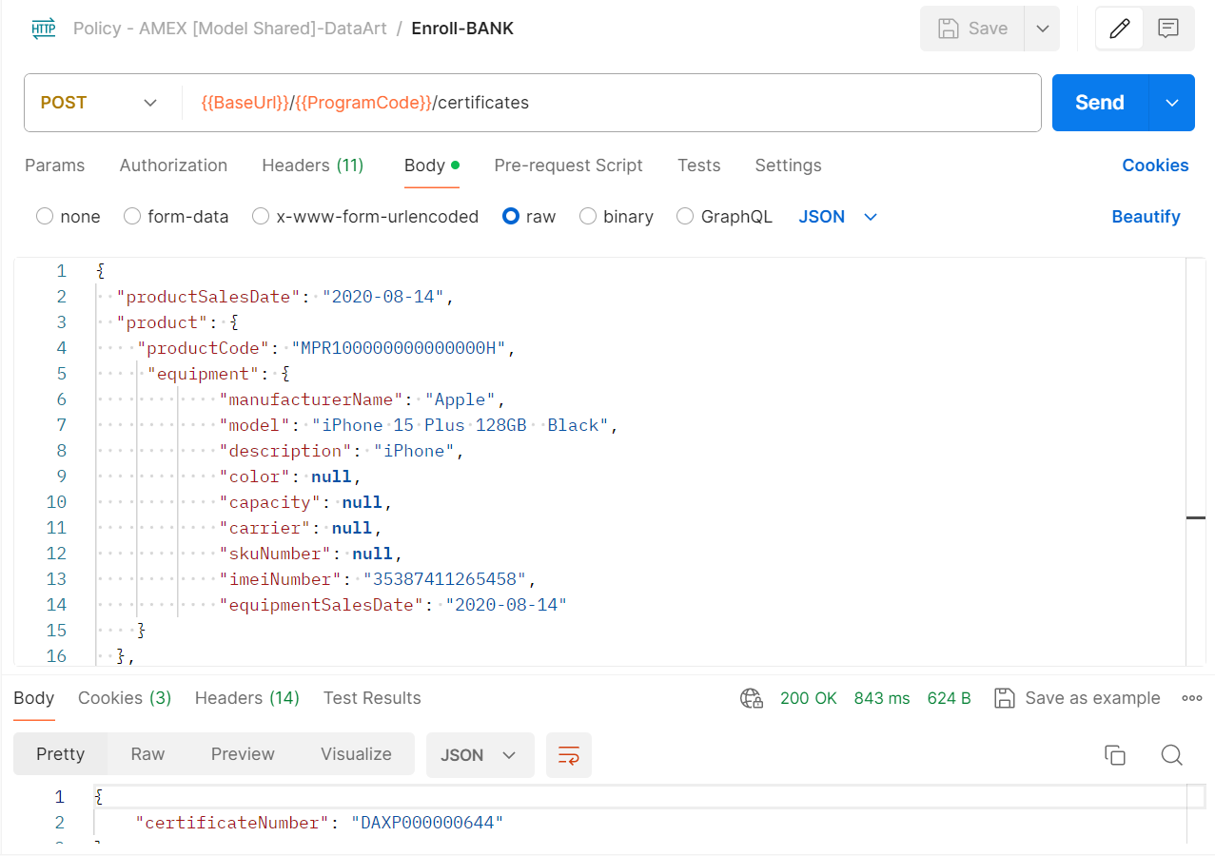
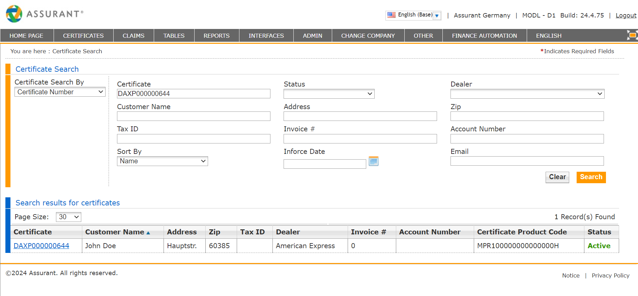

/{{ProgramCode}}/certificates?phoneNumber=1234567890

This GET API is used to search certificate based on following query parameters
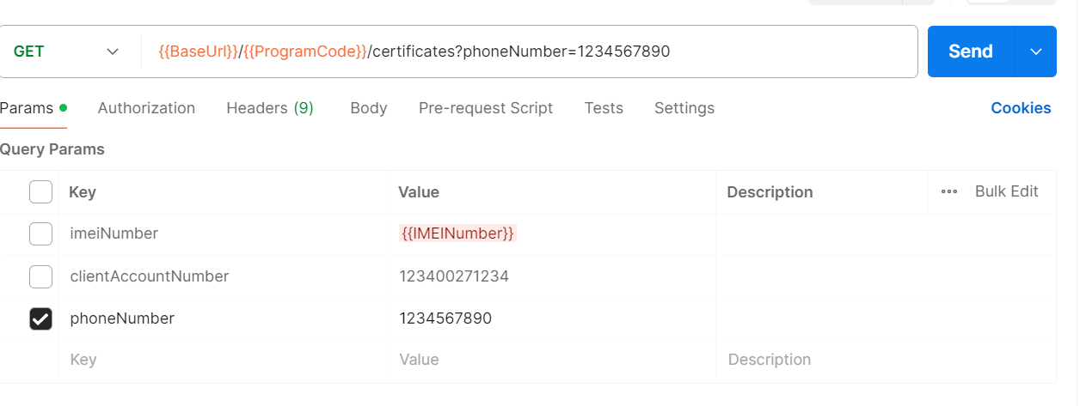

Headers

Following Headers are required to call Search Certificate
Header Key | Value | Description
Ocp-Apim-Subscription-Key | APIM Subscription Key | Key used to connect with Azure APIM instance
Authorization | Bearer Token | Token received from Get Token API based on client id and secret

Response
[
{
"certificateNumber": "DAXP000000101",
"dealerCode": "AMEX",
"status": "Active",
"productSalesDate": "2020-08-14",
"warrantySalesDate": "2020-08-14",
"productActivationDate": "2020-08-14",
"product": {
"productCode": "MPR100000000000000H",
"equipment": {
"clientSkuNumber": "SAMG00123423",
"manufacturerName": "Apple",
"model": "iPhone 15 Plus 128GB Black",
"description": "iPhone 15 Plus",
"imeiNumber": "35387411265458",
"equipmentSalesDate": "2020-08-14"
}
},
"certificateReferenceData": {
"clientReferenceNumber": "0190727851234"
},
"customers": [
{
"firstName": "John",
"lastName": "Doe",
"homePhone": "1234567890",
}
]
}]

Get – /{{ProgramCode}}/certificates/{{CertificateNumber}}

This GET API is used to retrieve certificate from Elita based on Certificate Number passed in url.

Headers

Following Headers are required to call Get Policy

Header Key | Value | Description
Ocp-Apim-Subscription-Key | APIM Subscription Key | Key used to connect with Azure APIM instance
Authorization | Bearer Token | Token received from Get Token API based on client id and secret

Response
{
"certificateNumber": "DAXP000000014",
"status": "Active",
"productSalesDate": "2020-12-30",
"productActivationDate": "2020-12-30",
"product": {
"productCode": "MPR1APL",
"clientProductCode": "MPR1APL",
"claimStartDate": "2020-12-30",
"productDuration": "12",
"equipment": {
"equipmentDefinitionId": "7f2c53cf-7d24-1c40-e053-845ced0a0f6c",
"manufacturerId": "f6d27247-dd85-4232-b6a5-22b2b58ccc45",
"manufacturerName": "Apple",
"model": "iPhone 12 Pro 512GB Graphite",
"description": "iPhone 12 Pro 512GB Graphite",
"color": null,
"capacity": null,
"carrier": null,
"clientSkuNumber": "iPhone",
"equipmentTypeId": "f6d27247-dd85-4232-b6a5-22b2b58ccc45",
"equipmentTypeName": "SMRT",
"serialNumber": "352262595100004",
"imeiNumber": "352162595176273",
"equipmentSalesDate": "2020-12-30",
"equipmentSalesPrice": 629
},
"coverages": [
{
"certificateCoverageId": "4f4562fd-fbdc-a436-e053-845ced0af116",
"coverageTypeCode": "B",
"beginDate": "2020-12-30",
"endDate": "2021-12-29"
},
{
"certificateCoverageId": "4f4562fd-fcdc-a436-e053-845ced0af116",
"coverageTypeCode": "A",
"beginDate": "2020-12-30",
"endDate": "2021-12-29"
}
]
},
"payment": {
"instrument": {
"instrumentType": "Other",
"authorizationNumber": "PRF-6199619133",
"authorizationSource": "External"
}
},
"branch": {
"name": null,
"code": "4992532",
"address": {
"address1": null,
"address2": null,
"address3": null,
"city": null,
"state": null,
"postalCode": null,
"country": null
},
"contact": {
"name": null,
"phone": null,
"fax": null,
"email": null
}
},
"certificateReferenceData": {
"clientReferenceNumber": "33122998913888"
},
"clientReferenceData": [
{
"name": "PaymentReferenceNumber",
"value": "PRF-6199619133"
}
],
"customers": [
{
"customerId": "4f4562fd-f1dc-a436-e053-845ced0af116",
"firstName": "Anne",
"middleName": null,
"lastName": "de Laulanié",
"firstNamePronunciation": null,
"lastNamePronunciation": null,
"nationality": "DE",
"birthPlace": {
"dateOfBirth": "1970-03-17",
"cityOfBirth": "Berlin",
"countryOfBirth": "DE"
},
"gender": null,
"maritalStatus": null,
"addresses": [
{
"addressee": {
"firstName": "Anne",
"lastName": "de Laulanié"
},
"address1": "45",
"address2": null,
"address3": null,
"city": "Berlin",
"state": null,
"postalCode": "12103",
"country": "DE"
}
],
"homePhone": "+330207090589",
"cellPhone": "+330327592467",
"emailAddress": "anne.delaulanie@assurant.com",
"identifications": []
}
]
}

Status Code: 200 OK
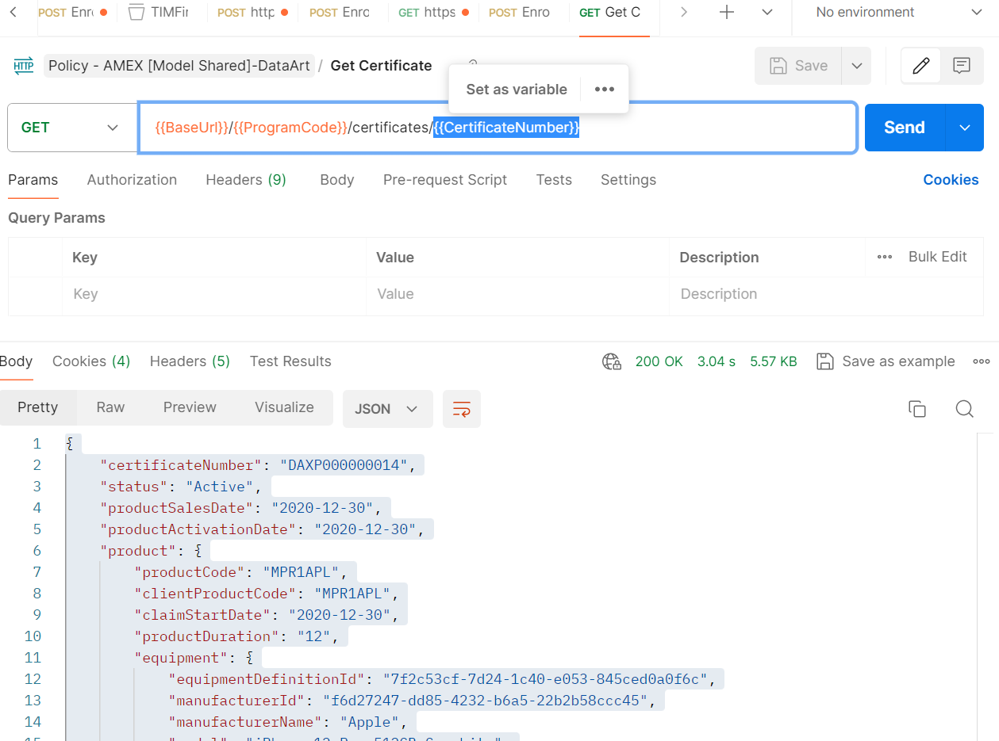
Status Code: 400 Not Found
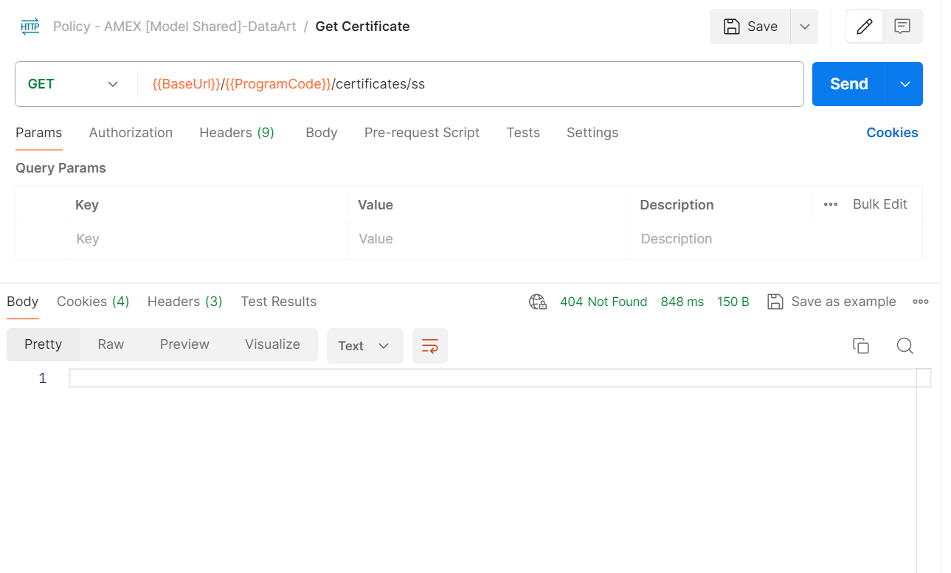

Get – /{{ProgramCode}}/manufacturers

This Get API returns all the manufacturer from ELITA SOAP product service

Headers

Following Headers are required to call Get manufacturer Policy

Header Key | Value | Description
Ocp-Apim-Subscription-Key | APIM Subscription Key | Key used to connect with Azure APIM instance
Authorization | Bearer Token | Token received from Get Token API based on client id and secret

Response

[
{
"manufacturerId": "2d9d48d0-b525-eb25-e053-845ced0a0d9e",
"name": "ALCATEL"
},
{
"manufacturerId": "f6d27247-dd85-4232-b6a5-22b2b58ccc45",
"name": "Apple"
},
{
"manufacturerId": "1203e4cf-e4f4-fb08-e053-845ced0a6f05",
"name": "CAT"
},
{
"manufacturerId": "5d0cbf74-ee02-4bfa-9c87-60cb64ee8190",
"name": "Doro"
},
{
"manufacturerId": "2d9d48d0-b625-eb25-e053-845ced0a0d9e",
"name": "EMPORIA"
},
{
"manufacturerId": "1203e4cf-e5f4-fb08-e053-845ced0a6f05",
"name": "Fairphone"
},
{
"manufacturerId": "1203e4cf-e6f4-fb08-e053-845ced0a6f05",
"name": "Google"
},
{
"manufacturerId": "9daec443-3c94-4b1e-9504-9d9cf648515d",
"name": "Huawei"
},
{
"manufacturerId": "1203e4cf-e7f4-fb08-e053-845ced0a6f05",
"name": "Lenovo"
},
{
"manufacturerId": "1203e4cf-e8f4-fb08-e053-845ced0a6f05",
"name": "Motorola"
},
{
"manufacturerId": "1203e4cf-e9f4-fb08-e053-845ced0a6f05",
"name": "Nokia"
},
{
"manufacturerId": "b0b232ae-03c3-44e5-bfc3-06b83cb9fd6a",
"name": "Nothing"
},
{
"manufacturerId": "00000000-0000-0000-0000-000000000000",
"name": "OTHER"
},
{
"manufacturerId": "1203e4cf-eaf4-fb08-e053-845ced0a6f05",
"name": "Oneplus"
},
{
"manufacturerId": "1203e4cf-ebf4-fb08-e053-845ced0a6f05",
"name": "Oppo"
},
{
"manufacturerId": "bbb4d2e4-d1d3-420e-b56c-0b602a40d80d",
"name": "Samsung"
},
{
"manufacturerId": "1fc59182-2b5c-444a-8590-9e55199f917e",
"name": "T-Mobile"
},
{
"manufacturerId": "1203e4cf-ecf4-fb08-e053-845ced0a6f05",
"name": "Xiaomi"
}
]

Status Code: 200
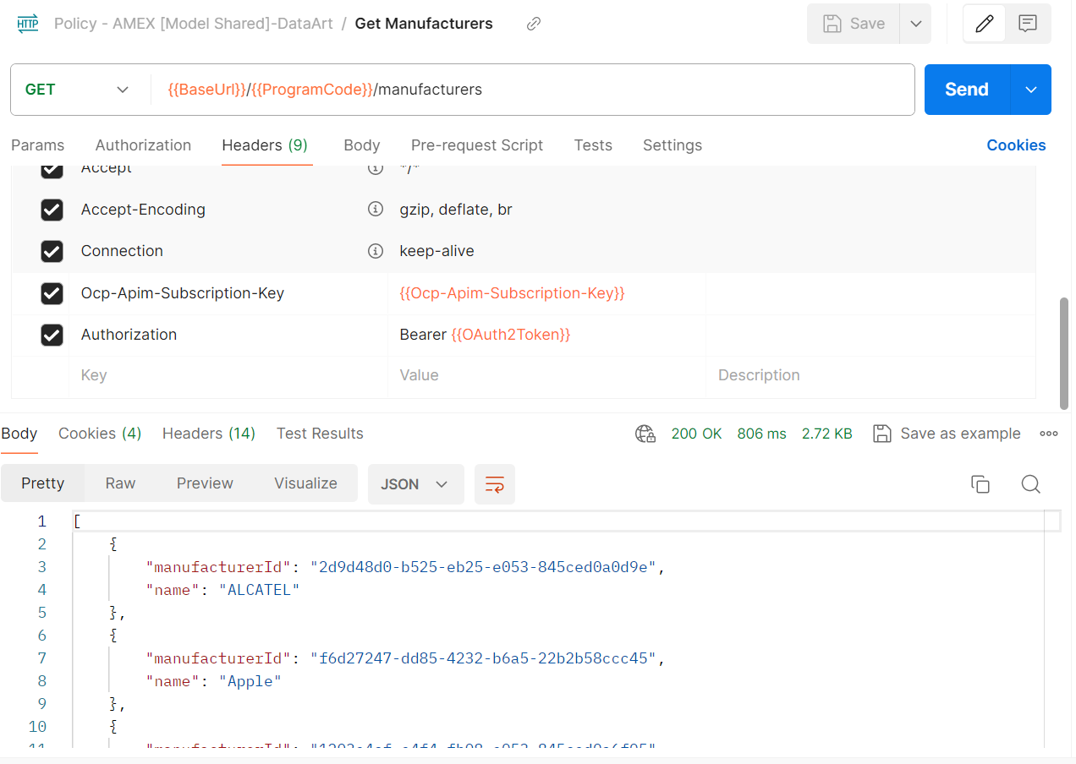

Get –/{{ProgramCode}}/equipments?manufacturerId=a0a499d8dc754b5a98871d2e3e001602

This api will return all the equipment based on manufacturer id fetched from manufacturer api

Headers
Following Headers are required to call equipment Policy

Header Key | Value | Description
Ocp-Apim-Subscription-Key | APIM Subscription Key | Key used to connect with Azure APIM instance
Authorization | Bearer Token | Token received from Get Token API based on client id and secret

Response

[
{
"equipmentDefinitionId": "fc134f0c-5ee7-6a0d-e063-845ced0acbd8",
"clientSkuNumber": "ZD661-17757",
"manufacturerId": "f6d27247-dd85-4232-b6a5-22b2b58ccc45",
"manufacturerName": "Apple",
"model": "iPhone 12 128GB Black",
"description": "iPhone 12",
"color": "BLACK",
"capacity": "128GB",
"carrier": null,
"equipmentTypeId": "ae8536d7-f20c-ddb4-e040-0a0aec046ee2",
"equipmentType": "SMRT"
},
{
"equipmentDefinitionId": "fc134f0c-55e7-6a0d-e063-845ced0acbd8",
"clientSkuNumber": "ZD661-17760",
"manufacturerId": "f6d27247-dd85-4232-b6a5-22b2b58ccc45",
"manufacturerName": "Apple",
"model": "iPhone 12 128GB Blue",
"description": "iPhone 12",
"color": "BLUE",
"capacity": "128GB",
"carrier": null,
"equipmentTypeId": "ae8536d7-f20c-ddb4-e040-0a0aec046ee2",
"equipmentType": "SMRT"
}]

Status Code: 200
If request is valid then following Json response will be returned with Status Code: 200
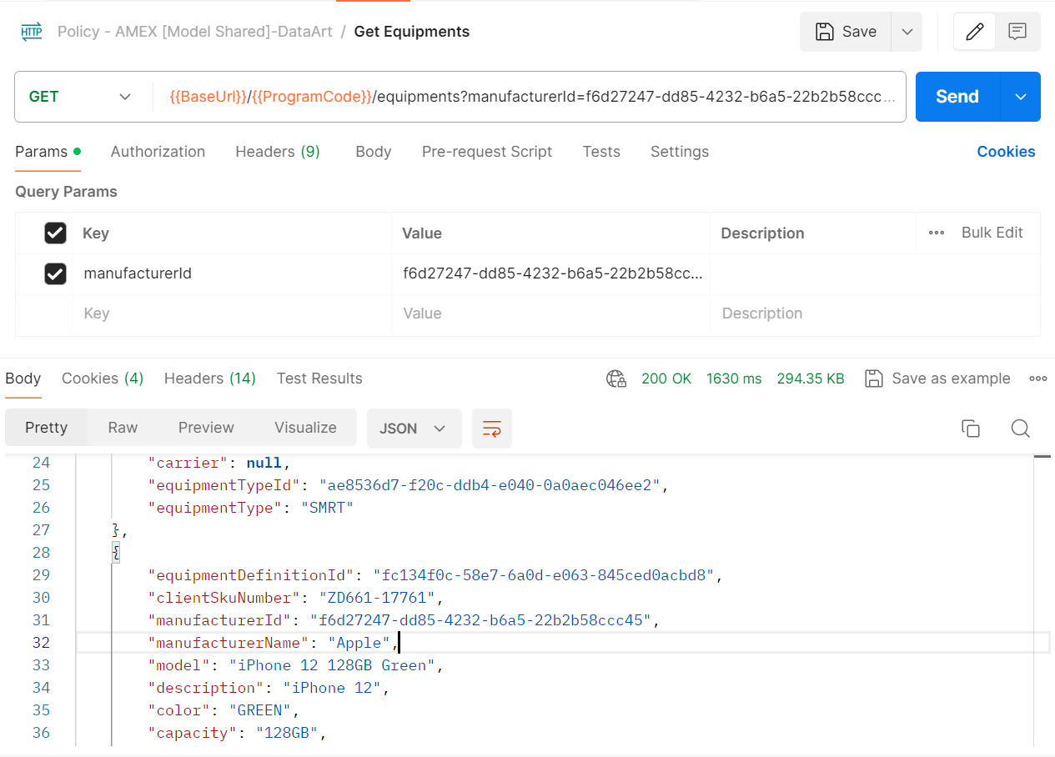

Get – /{{ProgramCode}}/products

This api can be used to Get products based on following query string params
equipmentDefinitionId: this is the retrieved from “Get Equipment” API response
IMEINumber: Imei number of a specific equipment. Result from “Get Equipment”
manufacturerName: manufacturer name of a specific equipment. Result from “Get Equipment”

Headers

Header Key | Value | Description
Ocp-Apim-Subscription-Key | APIM Subscription Key | Key used to connect with Azure APIM instance
Authorization | Bearer Token | Token received from Get Token API based on client id and secret

Response

Status Code: 200 OK

Get Product Journey

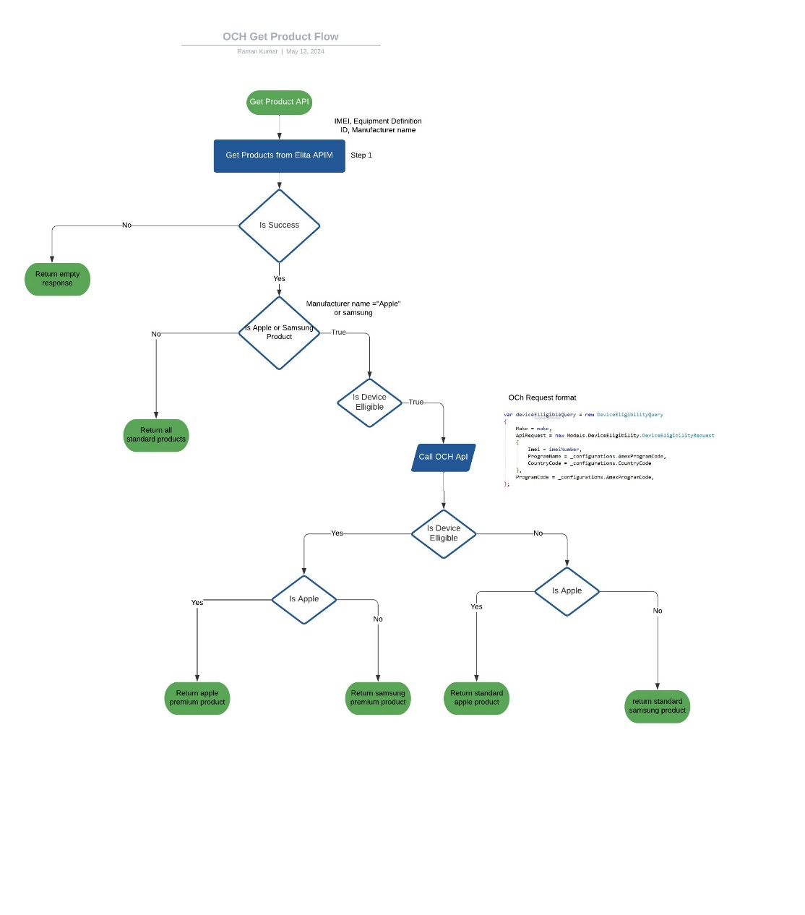

Debugging and Diagnostics
Application Insight in Azure bring us visibility about the requests that we get from the client and the impact in our components. The name of the Application Insight name can be extracted from the variable "AppInsightsName" in the pipeline library group Elita-SharedVariables-[Environment]-[Hub] in the target environment, for example: for AMEX in Model D1 the pipeline library group should be "Elita-SharedVariables-Model-D1" and the value for the variable "AppInsightsName" should be "ai-elita-modl-d1". Most of the troubleshooting can be done using these three application insight tables: requests, dependencies and exceptions.

requests | Capture the incoming requests to APIM or Function App
dependencies | Capture information related to a specific operation (request)
exceptions | List the exceptions reported to application insight.

Resource Detail

AMEX deployment details

The AMEX project has following components.

Variable | Value | Description
Function App Name | fa-amex-sales-modl-d1 | The app services plan used to deploy the function app for AMEX
APIM Name | apim-de-model | APIM where all apis are deployed
App insight name | Ai-elita-modl-d1 | Name of the app insight
Library Groups | AMEX-Sales-Test-D1  AMEX-Sales-Model-D1  AMEX-Sales-Producton-DE | All variables defined in this library for AMEX API. This variable group contains all OCH api details and apple and samsung premium product list

Reference

- Azure APIM
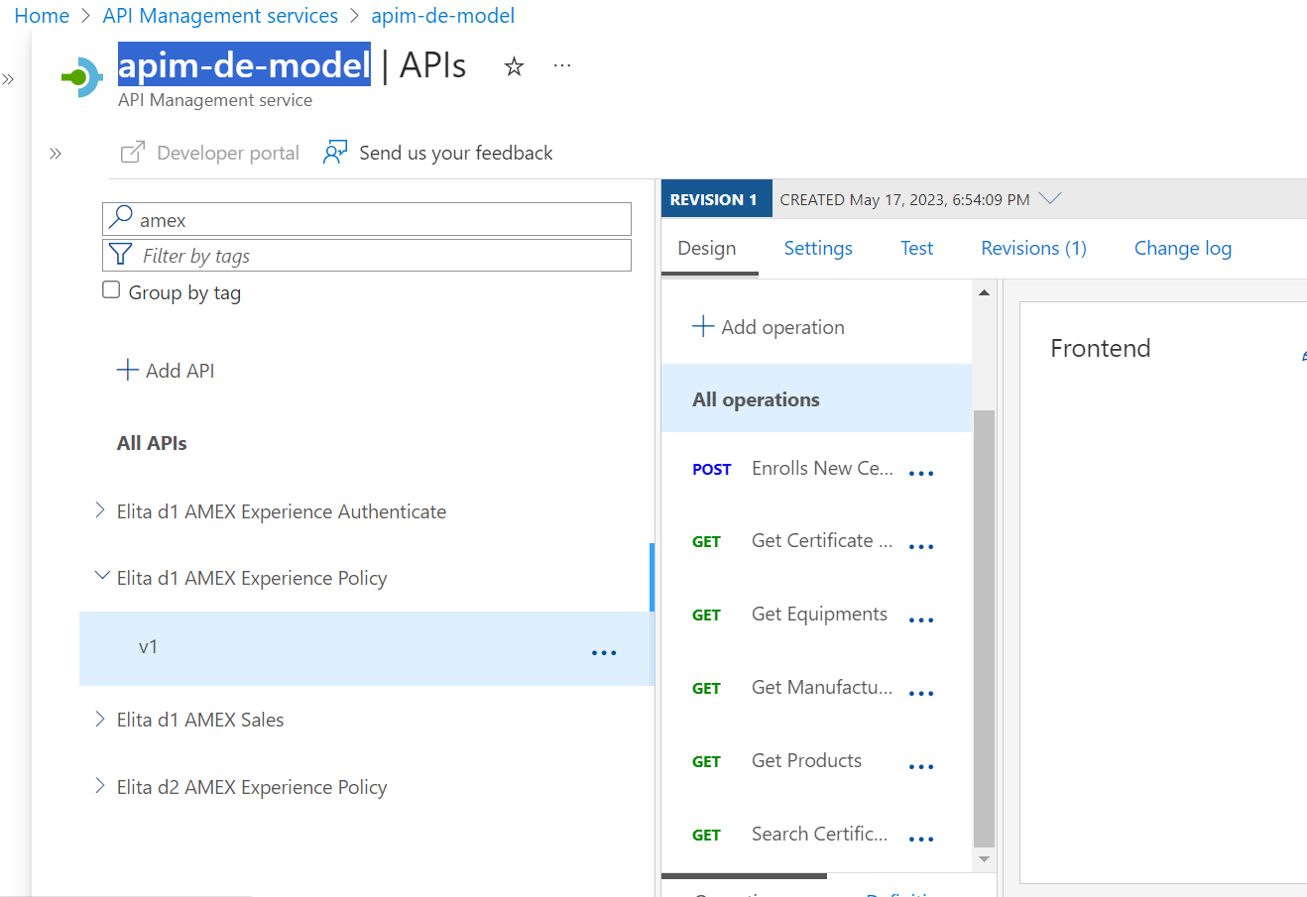

- Function app name

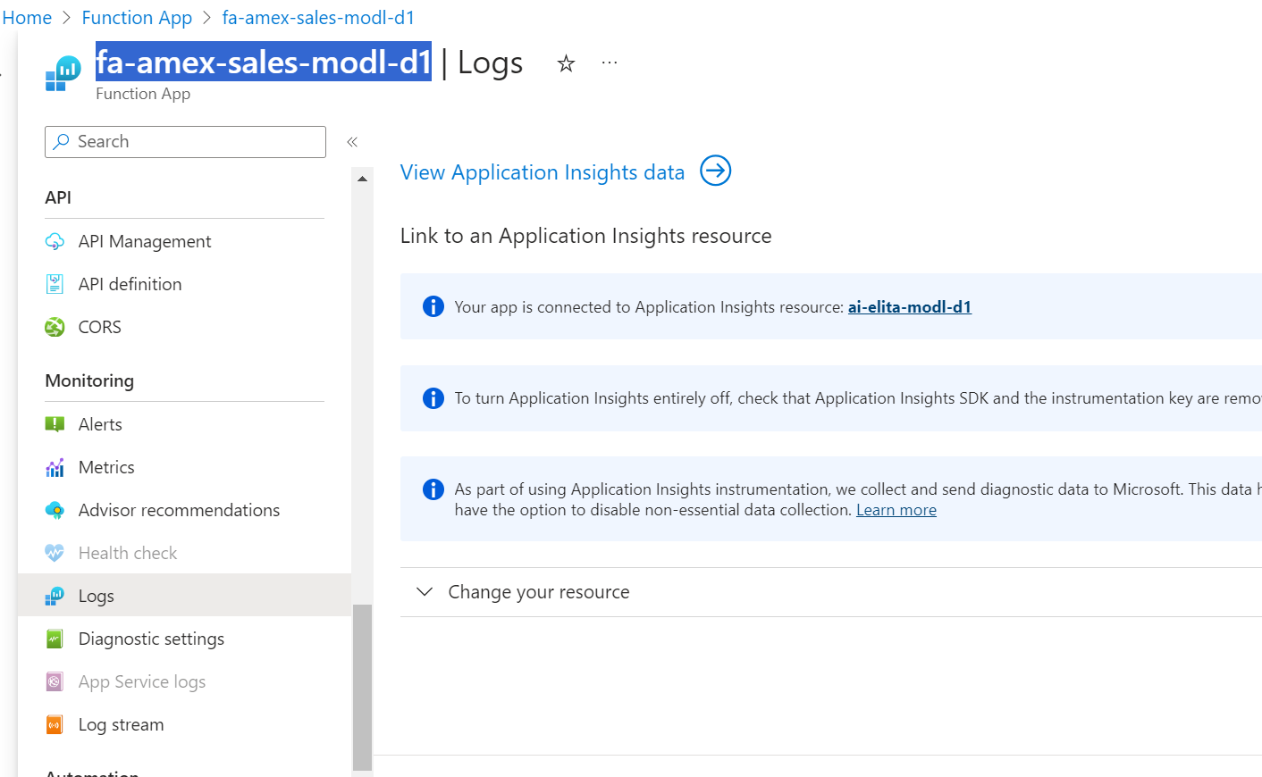

- Variable Group

